SD5730 规格书 暖白光

◆Features:
◆Super high flux output and high luminance ◆Extremely wide viewing angle

◆Suitable for all SMT assembly and solder process ◆Available on tape and reel ◆Package:16K/reel
◆ROHS compliant

PART NO.：SD5730NWN1

ATTENTION

OBSERVE PRECAUTONS

FOR HANDLING

ELECTROSTATIC

DISCHARGE

SENSITIVE

DEVICES

◆ABSOLUTE MAXIMUM RATING （Ta=25℃）

Item | Symbol | Value | Unit
Peak Forward Current | IFp | 500 | mA
Reverse Voltage | VR | 5.0 | V
Continuous Forward Current | IF | 60 | mA
Recommend Operating Current | IF | 600 | mA
Operating Temperature | Topr | -40 to 85 | ℃
Storage Temperature | Tstg | -40 to 105 | ℃
Lead Soldering Temperature | Tsol | 250℃ For 3 Seconds

◆CHARACTERISTICS (Ta=25℃)
 | Parameter | Condition | Symbol |  |  | Min | Typ | Max | Units
 | Power Dissipation | IF=60mA | Pd |  |  | - | 0.2 | - | w
 | Correlated Color | IF=60mA | CCT |  |  | 2800 | - | 3000 | K
 | Temperature | IF=60mA
 | Forward Voltage | IF=60mA | VF |  |  | 2.8 | 3.3 | 3.8 | v
 | Reverse Current | VR=5V | IR |  |  | / | / | 10 | μA
 | Chromaticity | IF=60mA | X |  |  | / | 0.31 | /
 | Coordinates
 | Coordinates | IF=60mA | Y |  |  | / | 0.33 | /
 | Luminous Flux | IF=60mA | φv |  |  | 30 | / | 40 | LM
 | Color Rending Index | IF=60mA | CRI |  |  | / | 70 | / | Ra
 | Full Viewing Angle | IF=60mA | 2θ1/2 |  |  | / | 120 | / | deg
 | ◆PACKAGE DIMENSIONS |  |  |  | ◆实物图
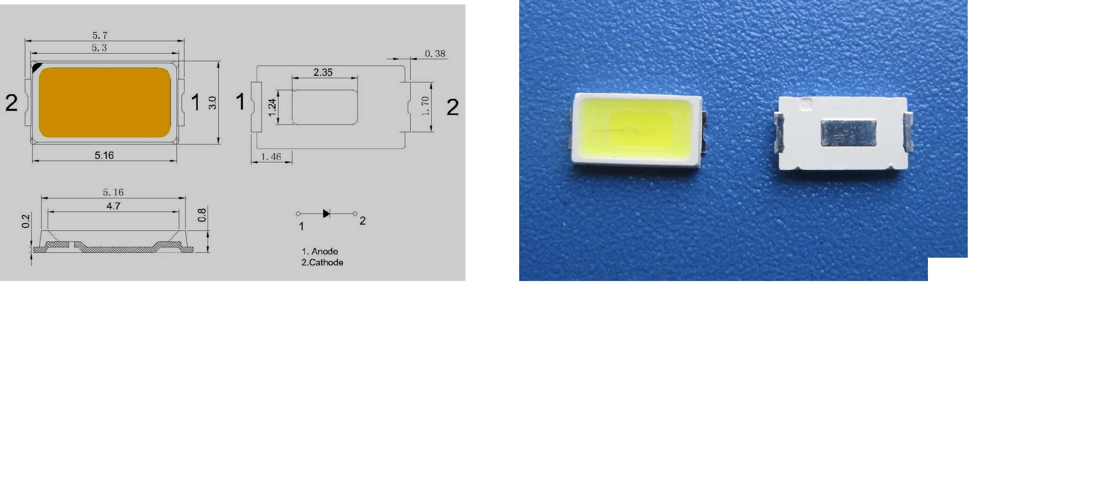
REMARK：1:1
Date | 2013-10-15 | Page | 1/1 | Model No. | SD5630NWN1 | CHECKED
REV No. | A1 | Document No. | 1905637002 | CUSTOMER |  | APPROVED

NOTE： Testing tolerance: VF±0.1V, IV(Φv) ±10%, 2θ1/2 ±10% ，CCT（λD）±15%;

